**Endpoint Testing**

Add the input_s3_uri key in the body and the value should be the s3 video file uri

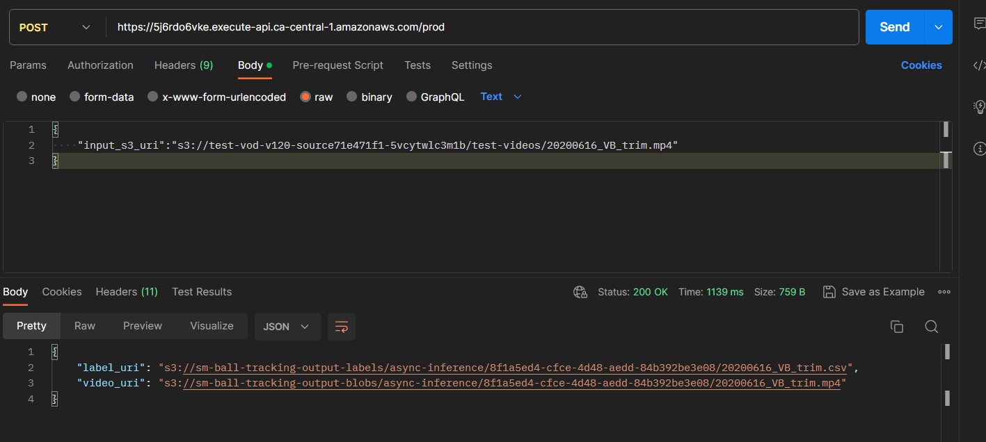

2 headers are expected:

1. x-api-key: The dynamic api key generated
2. Api-Pass: password

You can change both of them later. the steps and details for which are added in Readme.md file under infra folder in source code)

You can see the output response which contains the location of labels in output video respectively. Please note even though this response will be immediately returned, the actual inference can take time depending upon the input video file size. Until the output video is actually uploaded to S3 (when the inference is completed). If you try to access this s3 path programmatically you will get NoSuchKey error.

Alternatively you can simply test the endpoint by running the test.py file in the source code or if you want to directly invoke the sagemaker endpoint, the code is there in sagemaker.ipynb under Testing section at the bottom of the notebook.